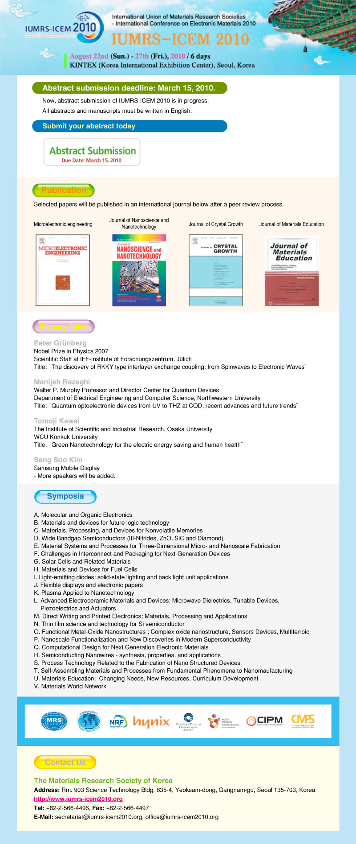

Symposium U
Materials Education: Changing Needs, New Resources, Curriculum Development

This Symposium invites papers from educators in materials, physics, chemistry, biosciences, and engineering, describing their recent achievements with creative teaching styles, new modular resources, and innovative curriculum development. Contributions from educators at all levels are welcome, including schools, universities, and centers for outreach to the general community. Either Oral or Poster presentations are welcome.

Call for Abstracts Suggested Topics include:

- High school activities introducing Materials Sciences, and basic concepts
- Programs for High School teachers.
- Integrated science teaching, to link bio- nano- eco- related sciences.
- Software resources, web based instruction, modules, etc.
- Science Concepts for Everyone - Toward a science-literate world.
- Teaching the skills needed for job success in industry, technology, business.
- Undergraduate MSE curriculum and standards. ABET updates.
- Research experiences for undergraduates.
- Economics factors for technology supporting regional/national/international education
- International collaborations in Materials Education

Please submit abstracts at www.iumrs-icem2010.org

Deadline is March 31, 2010.

Publication Manuscripts may be published in the Journal of Materials Education.

Symposium Organizers:

John E.E. Baglin
IBM Almaden Research Center, K10/D1
650 Harry Road
San Jose, CA 95120, USA
Tel.: +1 408 927 2280
E-mail: baglin@almaden.ibm.com
Hyuck Mo Lee
KAIST (Korea Advanced Institute of Science and Technology)
Department of Materials Science and Engineering
335, Gwahangno, Yuseong-gu, Daejeon, 305-710, Korea
Tel: +82-42-350-3334
E-mail: hmlee@kaist.ac.kr

This Symposium is supported and endorsed by the International Council on Materials Education

